Name | Arsh Raina
UID no. | 2021600053
Experiment No. | 7

AIM: | Implement various text processing problems.
Program 1
PROBLEM STATEMENT : | Write a program to count the number of vowels, consonants, total characters and words in the given string.
ALGORITHM: | Step 1: Declare a string and input its value.  Step 2: Declare integer variables vowels, spaces and consonants all equal to 0.  Step 3: Create an array vow containing all vowels and another array cons containing all consonants.  Step 4: Run a for loop for variable i where values of i are in range 0 to length of string. Inside first loop run a for loop for variable j where values of j are in range 0 to 10. If string[i] equals vow[j] increment value of vowels by 1. Inside first loop run another for loop for variable j where values of j are in range 0 to 42. If string[i] equals cons[j] increment value of consonants by 1.  Step 5: Run a for loop for variable i where values of i are in range 0 to length of string. If string[i] equals space increment value of spaces by 1.  Step 6: Print vowels, consonants, total characters equals length of string and total words equal to spaces+1.
PROGRAM: | 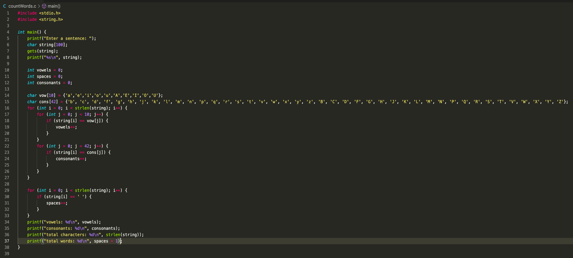
RESULT:
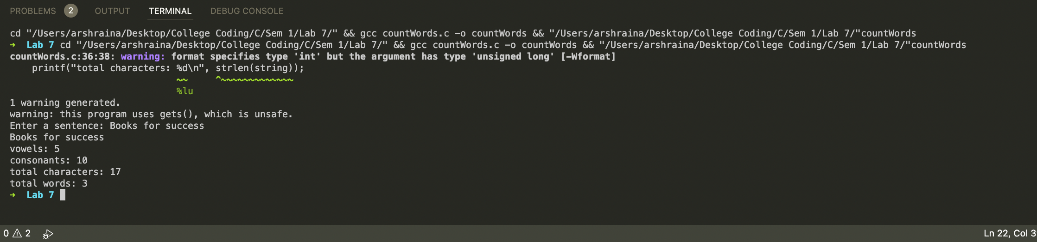
Program 2
PROBLEM STATEMENT : | Write a Menu driven Program to i)copy one string to another one by one character. ii) Find the string length iii) compare two strings iv) reverse the string v) Concatenate one string to another string. vi) lower case to upper
PROGRAM: | 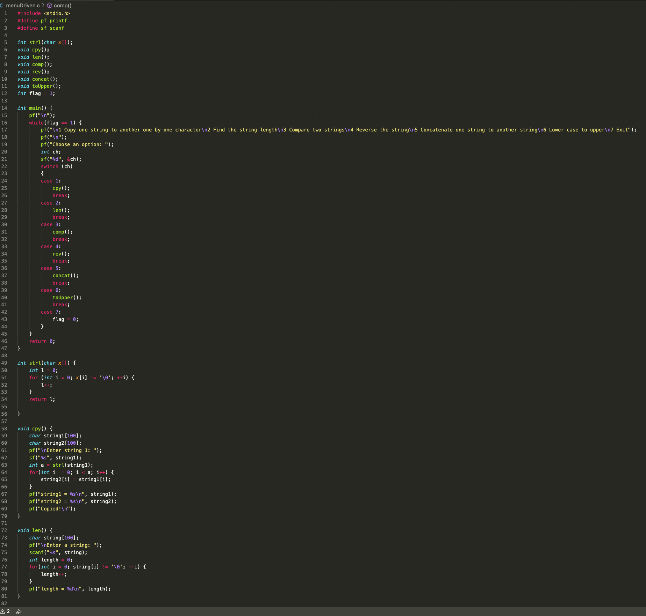  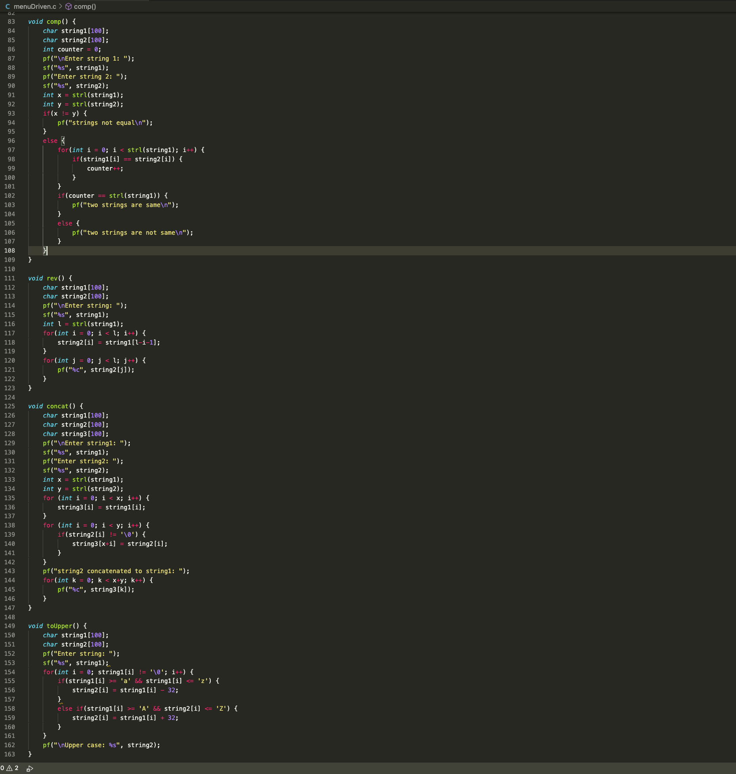
RESULT:
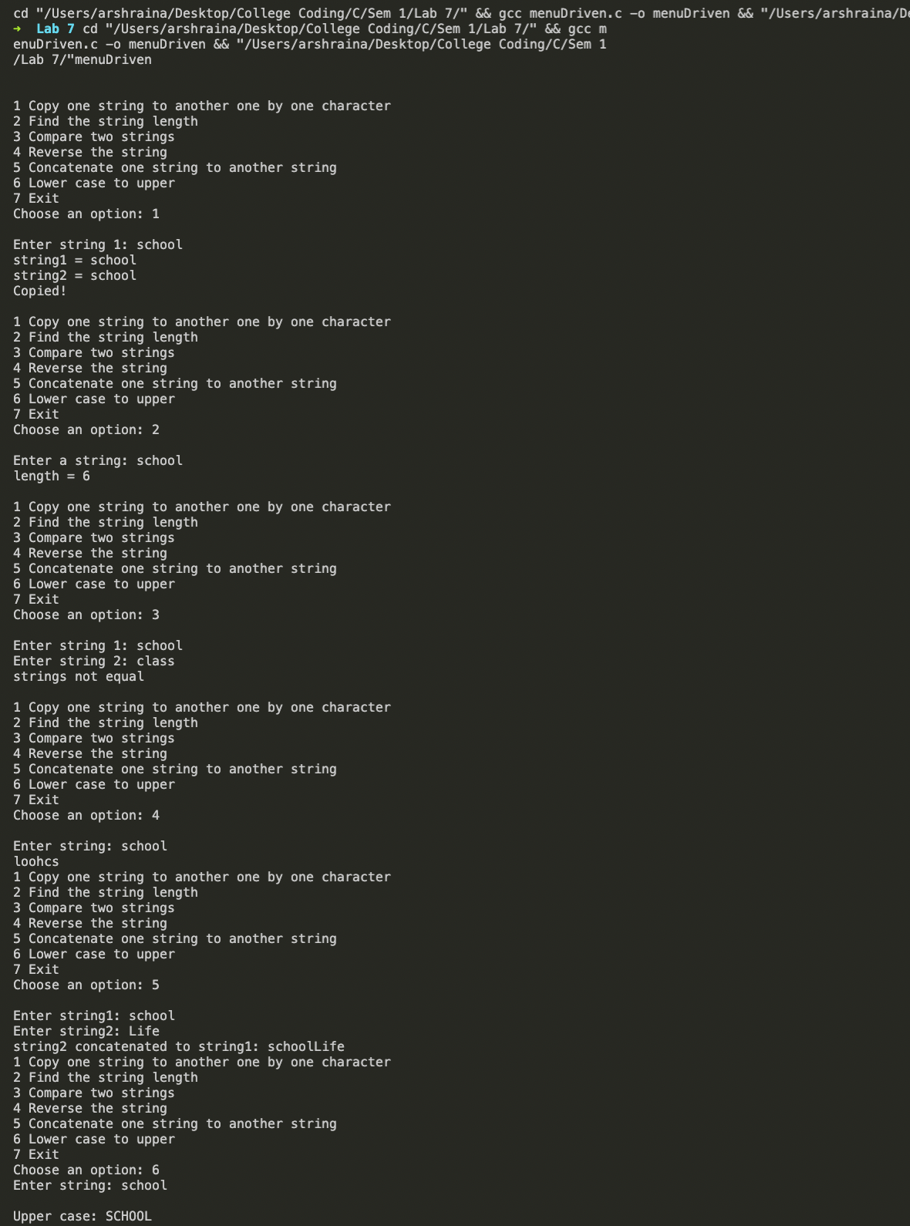
Program 3
PROBLEM STATEMENT: | Write a program to find and replace a particular word from the string. Input: I LOVE CANADA BECAUSE CANADA IS A GREAT COUNTRY Word to Find : CANADA Word to replace :INDIA Output:I LOVE INDIA BECAUSE INDIA IS A GREAT COUNTRY
PROGRAM: | 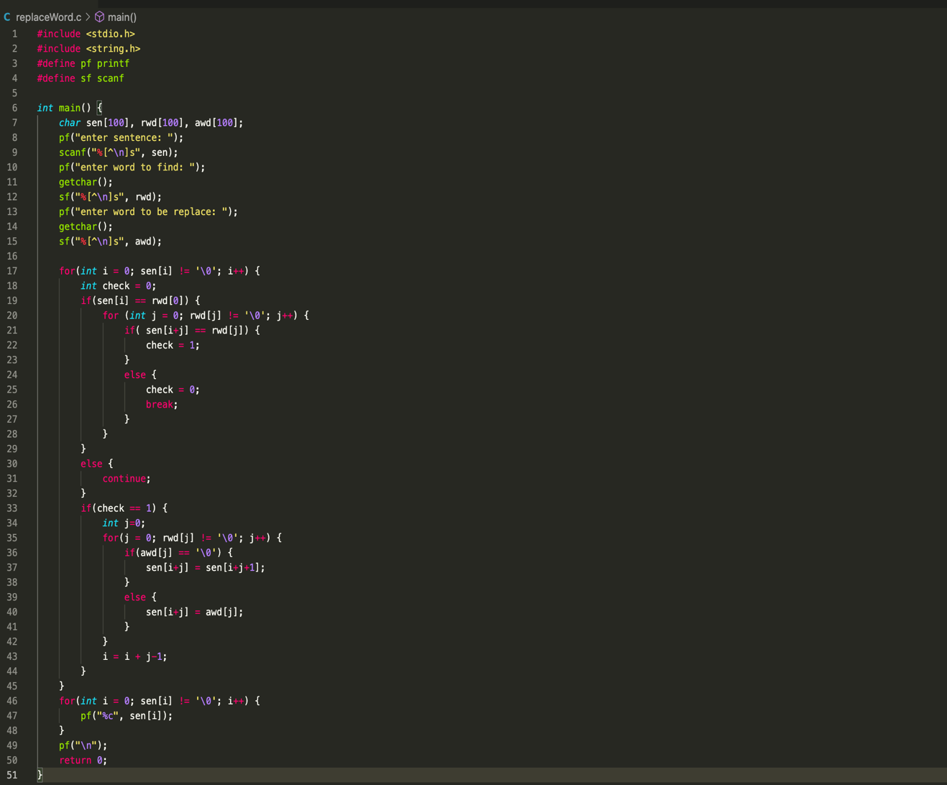
RESULT:
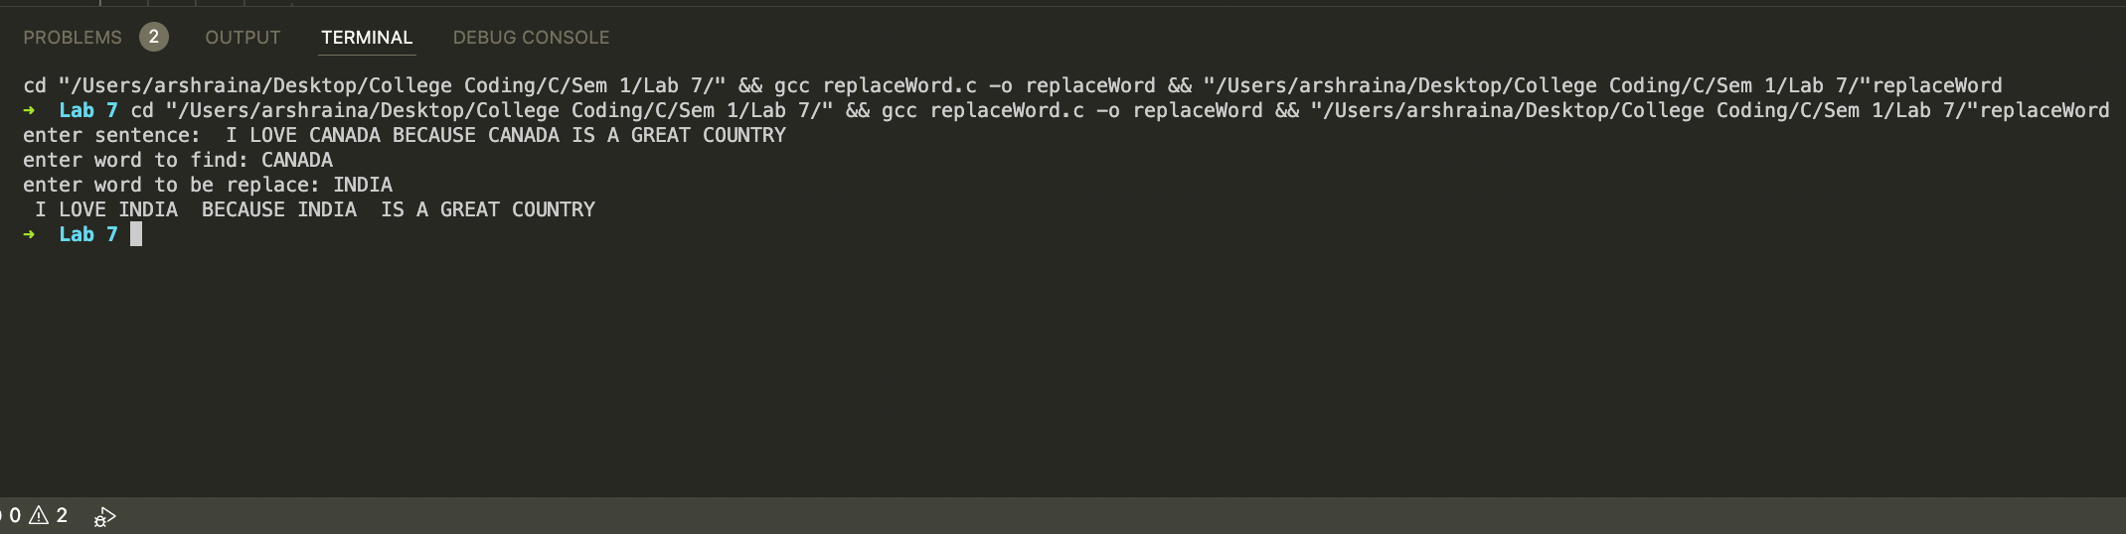
CONCLUSION: | Successfully implemented various text processing problems.

